696 DEPT WEBSITE

INTRODUCTION
Welcome to 696, where streetwear meets identity.

Born from raw expression and unapologetic creativity, 696 is more than just a clothing brand, it is a movement. We design for those who refuse to blend in, those who turn everyday streets into runways and self expression into art.

Every piece in our collection is crafted with purpose, bold graphics, premium fabrics, and a mindset that challenges the ordinary. Whether you are stepping out or standing out, 696 is built to represent confidence, individuality, and culture.

This is not just fashion.
This is 696!

1. WEBSITE SPECIFICATIONS
a. Website Objective
The main objective of the 696 DEPT website is to create a strong online presence and serve as an e-commerce platform for selling streetwear t-shirts.
Goals:
1.Sell branded streetwear t-shirts directly to customers
2.Build a recognizable urban fashion brand identity
3.ncrease brand awareness locally in Botswana
4.Provide a seamless online shopping experience

b. Target Audience
Primary Audience:
People aged 16-30, both male and female, mainly located in Gaborone and surrounding areas.
Technical Aptitude:
People who are comfortable using smartphones, social media and online shopping platforms.

c. Type of Website
The website will be a E-commerce + Brand Showcase Website showing product listings, About page, Shopping cart & checkout, Contact form as well as images and banners.

2.INFORMATION DESIGN & TAXONOMY
Sitemap

Home (index.html)
│
├── Shop
│ ├── All T-Shirts
│ ├── New Arrivals
│ ├── Best Sellers
│
├── Product Details Page
│
├── About 696 DEPT
│
├── Contact / Feedback
│
└── Cart

Site structure
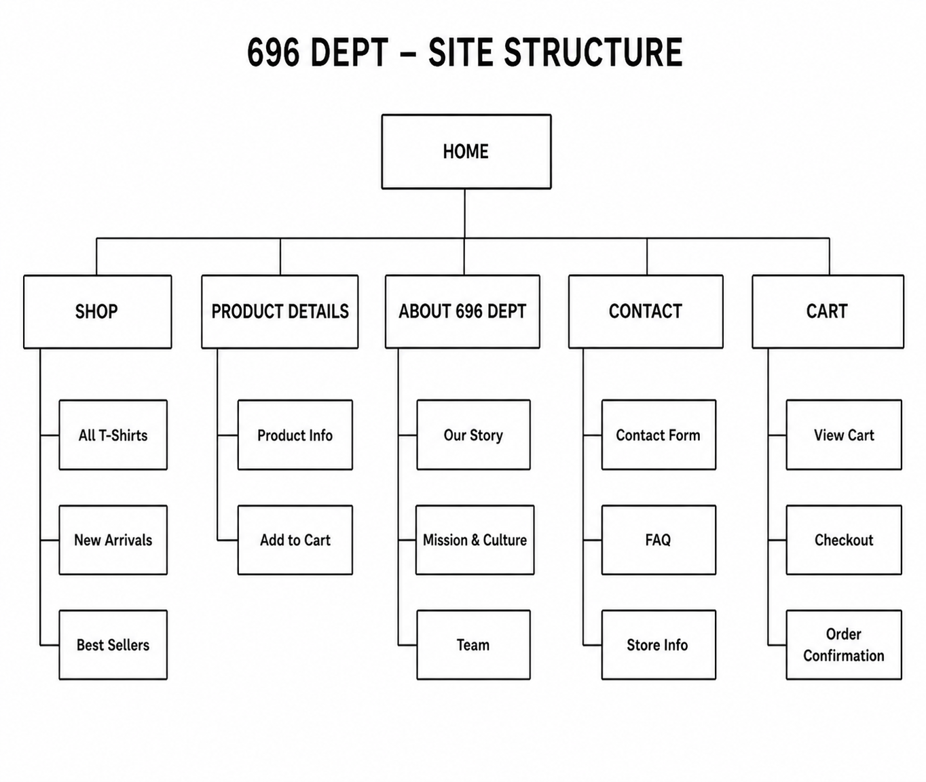
HOME
It will include a visually engaging banner that introduces the 696 brand, along with featured products, new arrivals, and promotional highlights. It will also contain navigation links to all major sections of the website, a brief brand introduction, and possibly call to action buttons such as “Shop Now” to guide user interaction.

SHOP
It will include a categorized display of all products available for purchase. This will consist of sections such as all t shirts, new arrivals, and best sellers. Each product listing will include images, names, and prices, allowing users to easily browse and select items of interest.
PRODUCT DETAILS
Will include detailed information about individual products. This will consist of high-quality images, product descriptions, available sizes, pricing, and material information. It will also include functionality for users to select options and add items to their cart.
ABOUT 696 will include information about the brand’s background and identity. It will feature sections such as the brand’s story, its mission and cultural values, and information about the team behind the brand. This page is intended to build trust and communicate the purpose of the brand.

CONTACT PAGE will include a contact form where users can submit inquiries or feedback. It will also contain a frequently asked questions section to address common customer concerns, as well as store information such as email address, phone number, and location details.

CART PAGE will include all elements required for completing a purchase. The cart section will display selected items, quantities, and total cost, while allowing users to update or remove items. The checkout section will include forms for entering shipping and payment details, and will conclude with an order confirmation page that provides a summary of the completed transaction.

Navigation Flow
- User lands on Home
- Clicks Shop
- Selects a product
- Views product details
- Adds to cart
- Proceeds to checkout

Taxonomy
Main Categories:
Products
Collections
Brand Content
Customer Interaction
Subcategories:
T-Shirts → Graphic / Plain / Limited Edition
Collections → New / Trending / Seasonal
Brand → Story / Mission / Culture

Storyboard
Homepage → Highlights brand + featured products
Shop Page → Displays all items
Product Page → Detailed product view
Cart → Purchase process
Contact Page → User interaction

3. TECHNICAL BRIEF
Technologies used;
HTML5 - Structure of pages
CSS3 - Styling and layout
Bootstrap - Responsive design
JavaScript - Interactivity (cart, buttons)

Development tools;
GitHub - Version control
GitHub Pages – Hosting

Graphic & design tools;
Figma- wireframes

PAGE TEMPLATE DESIGN
LOW FIDELITY
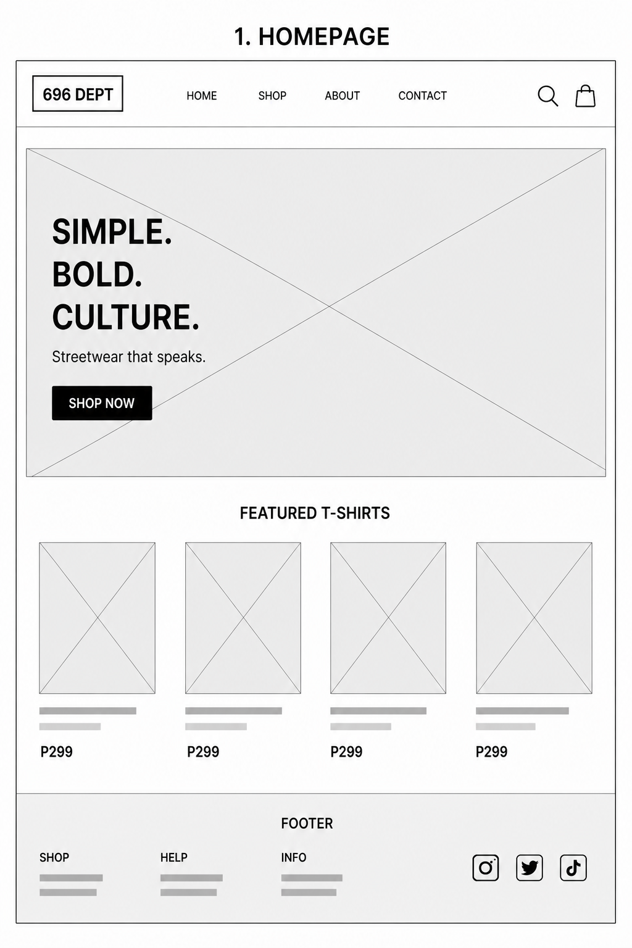
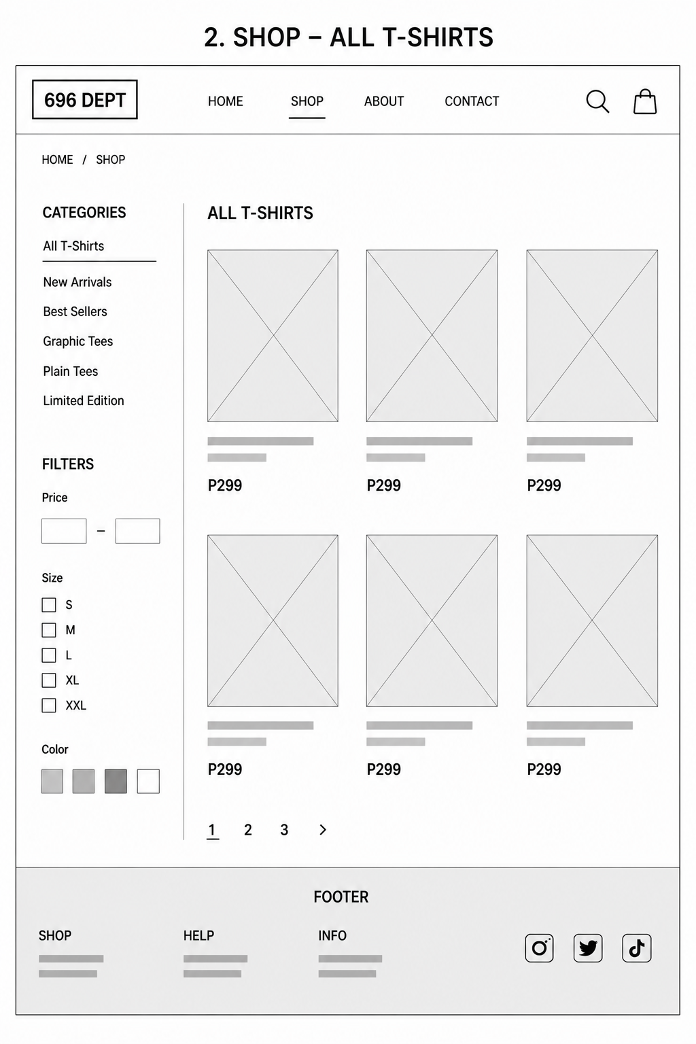
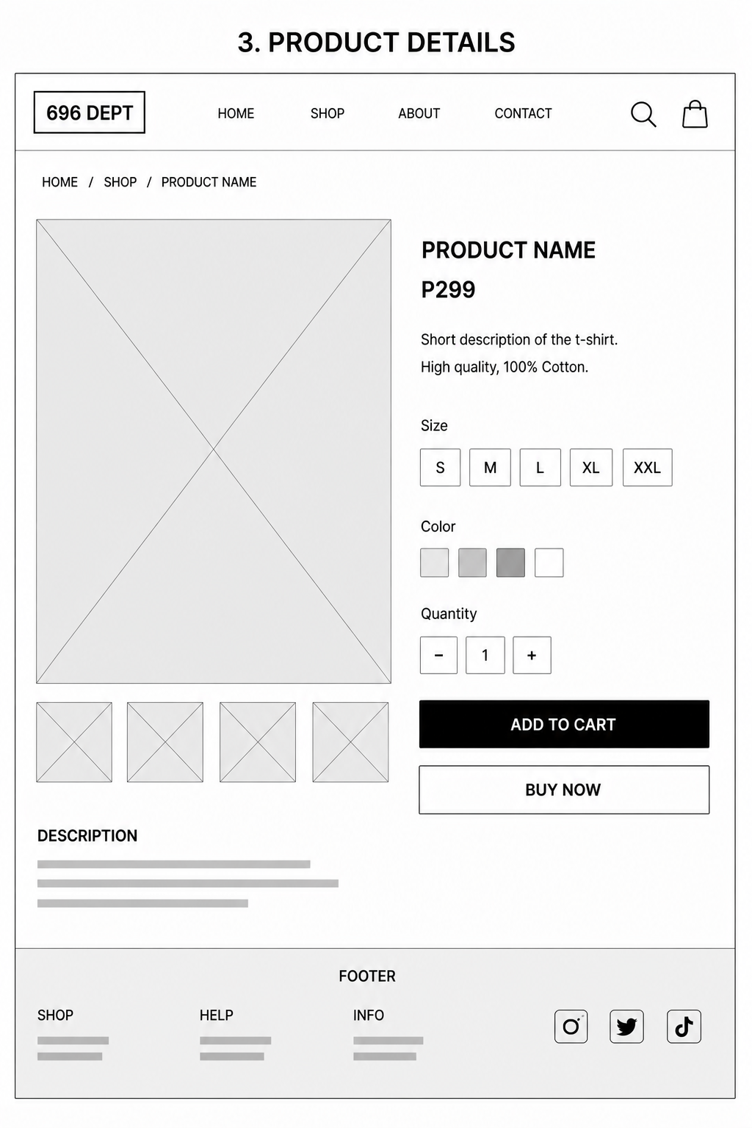
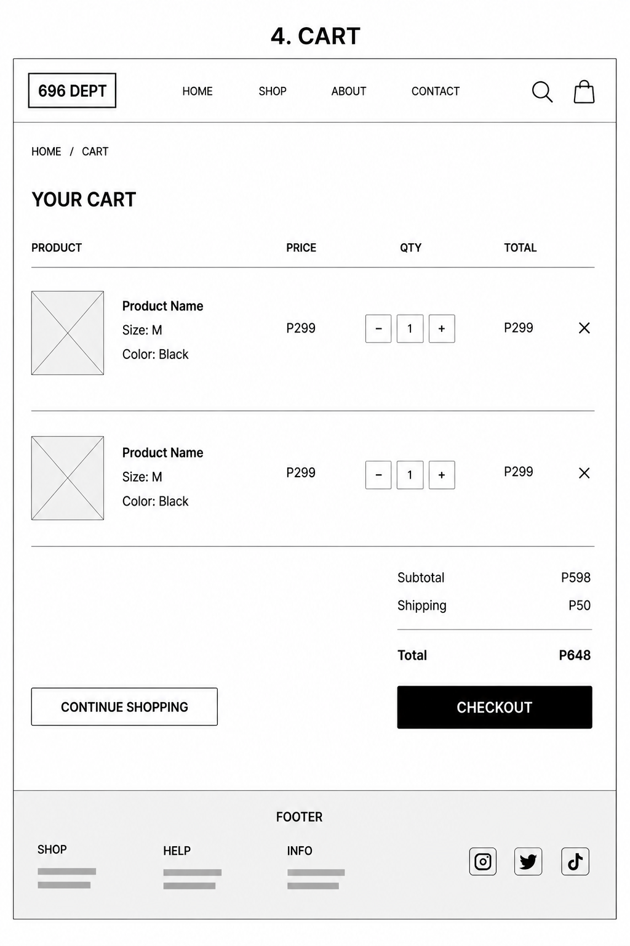
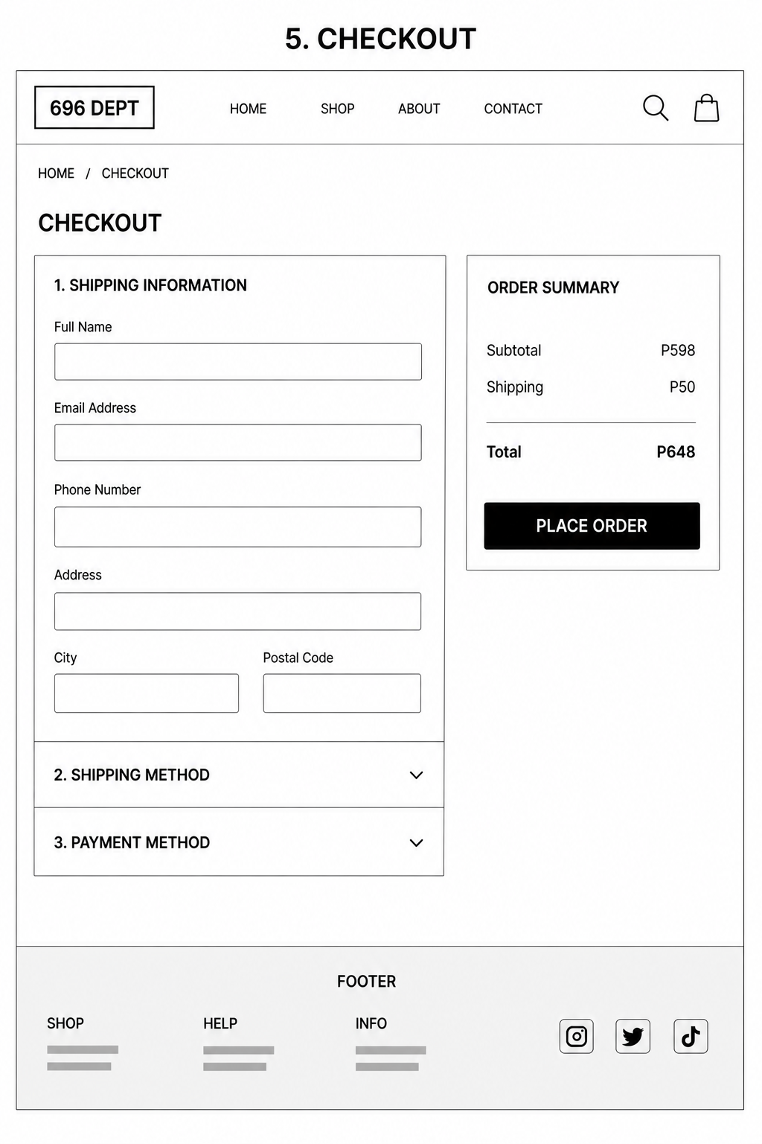
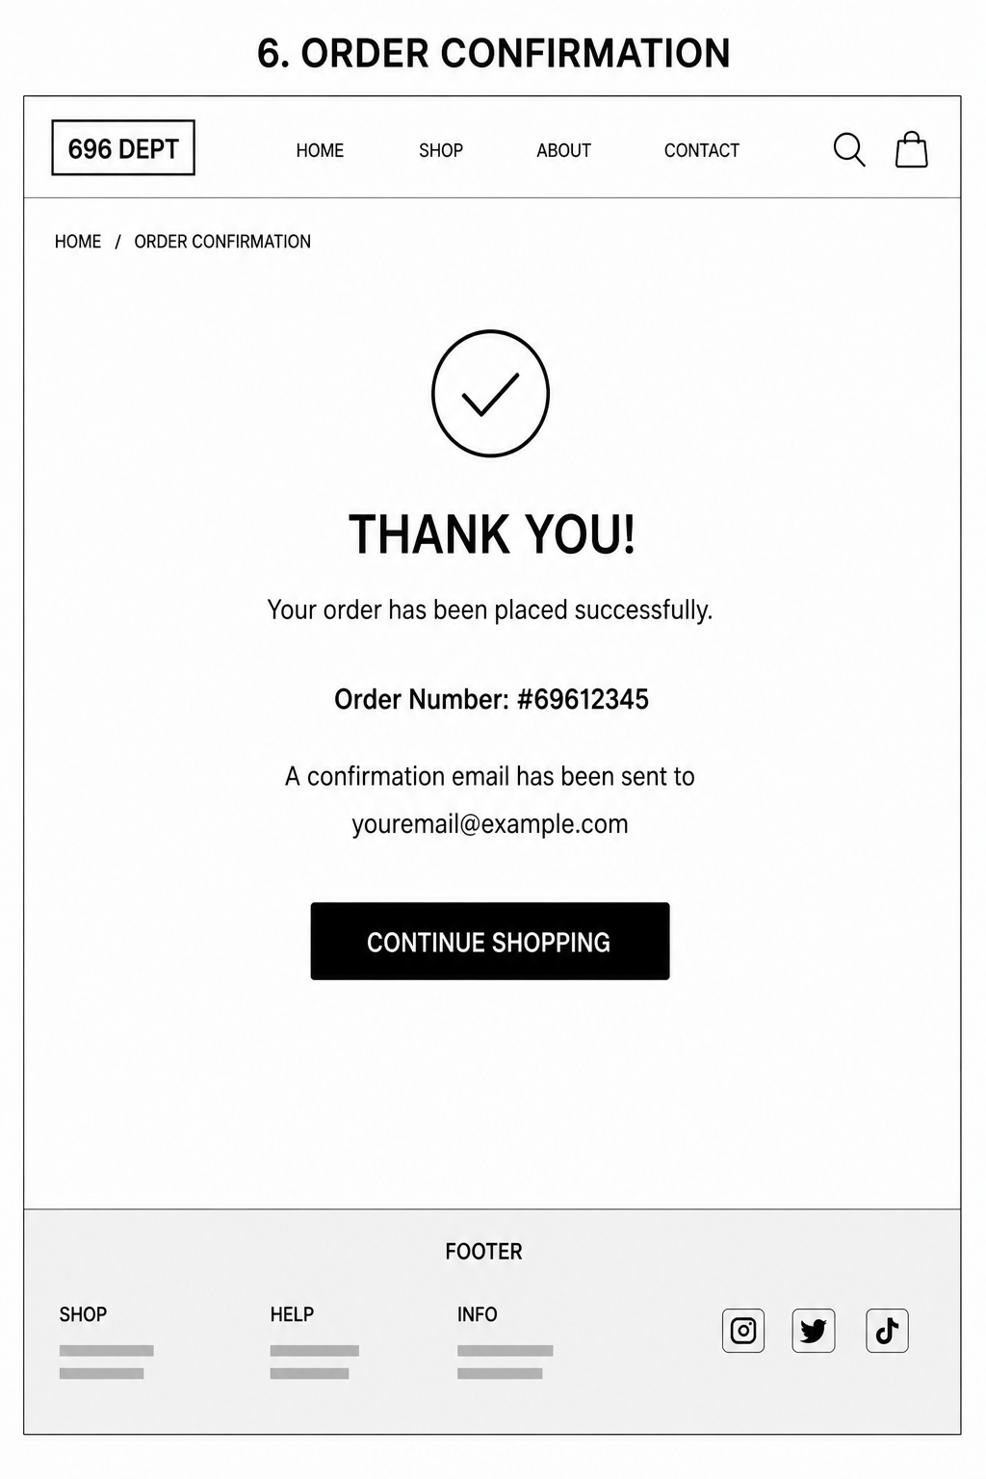
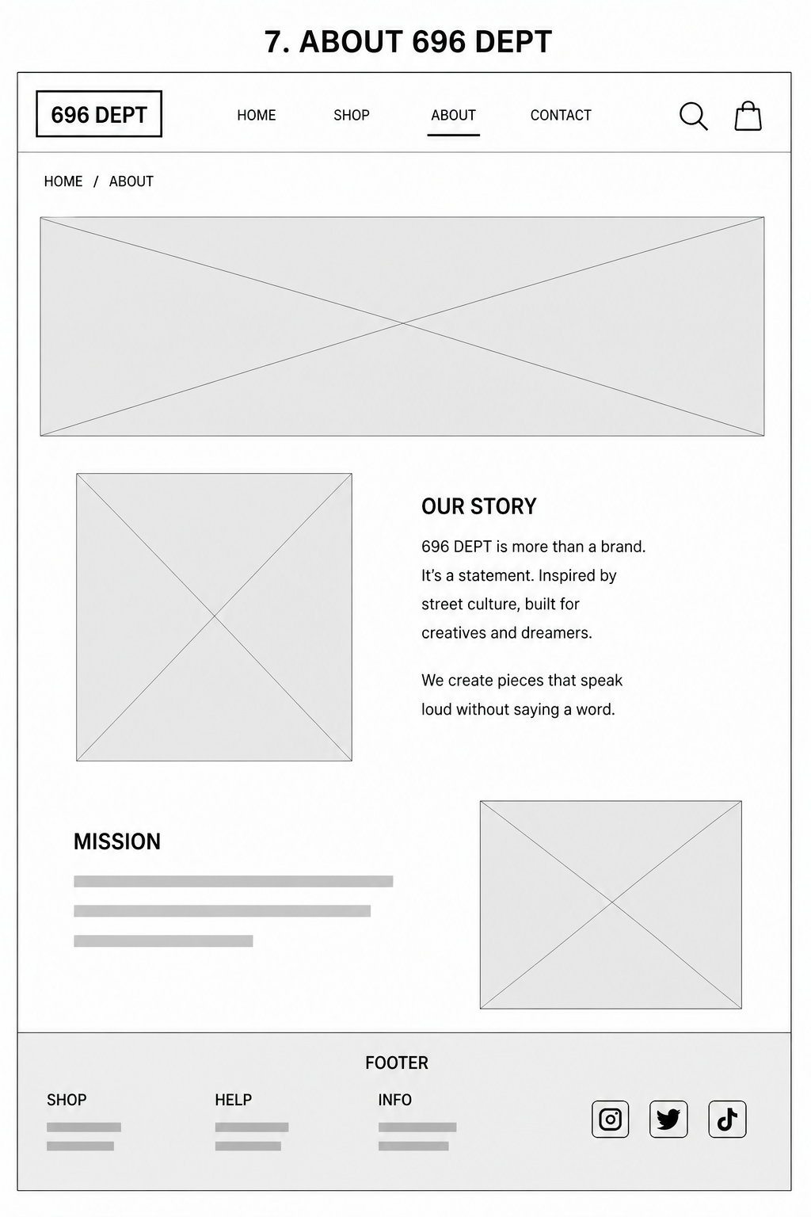
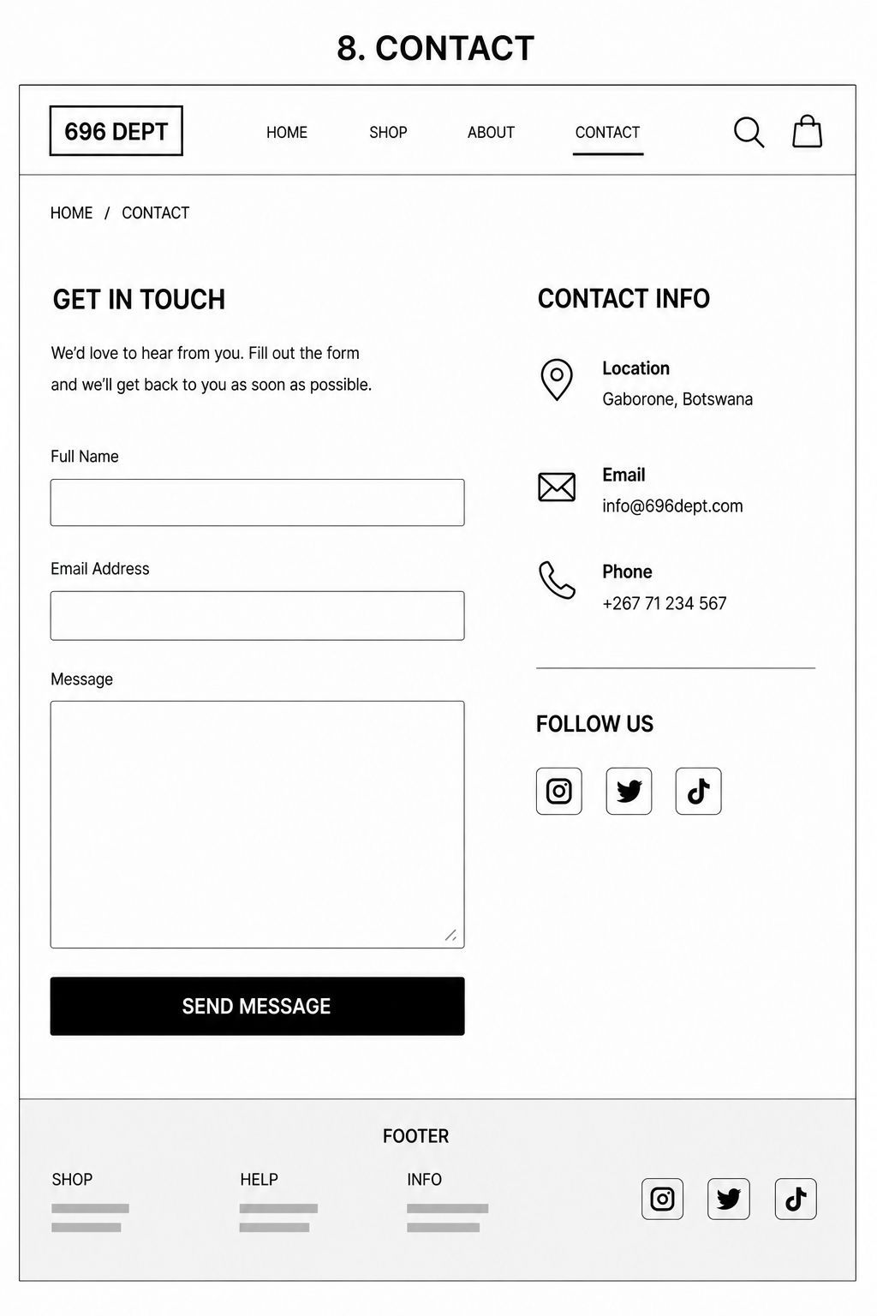
HIGH FIDELITY
HOME PAGE
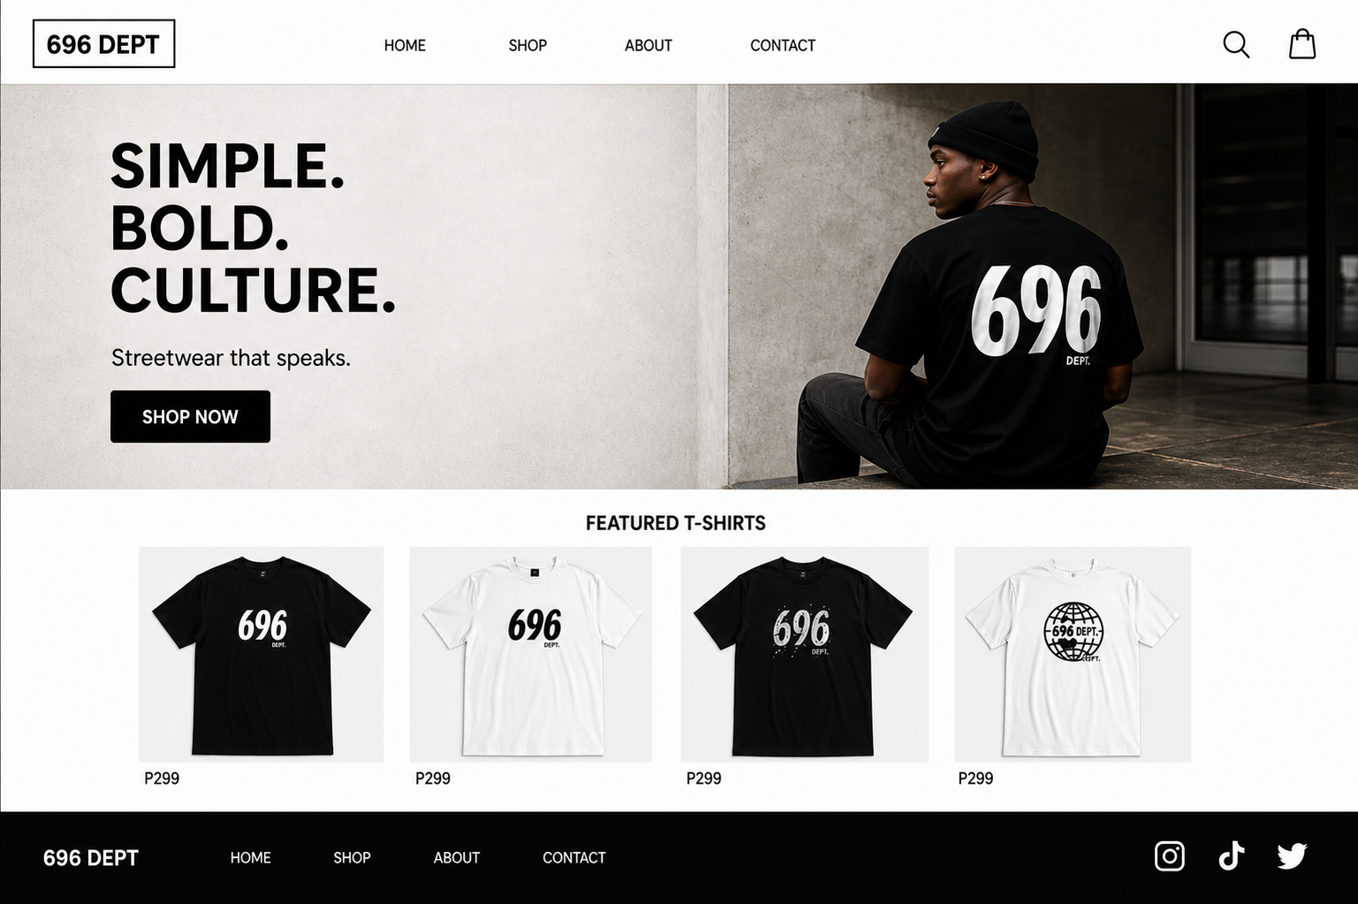
SHOP PAGE
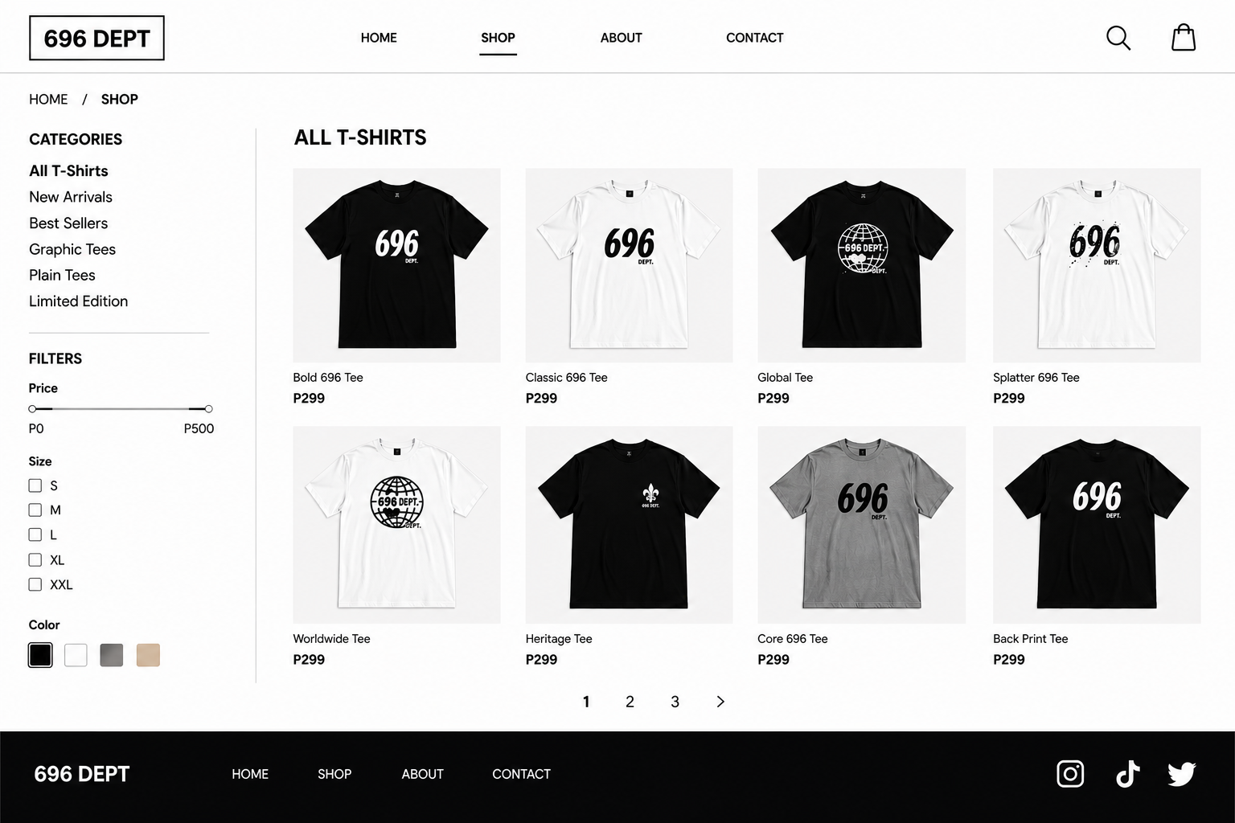

PRODUCT PAGE
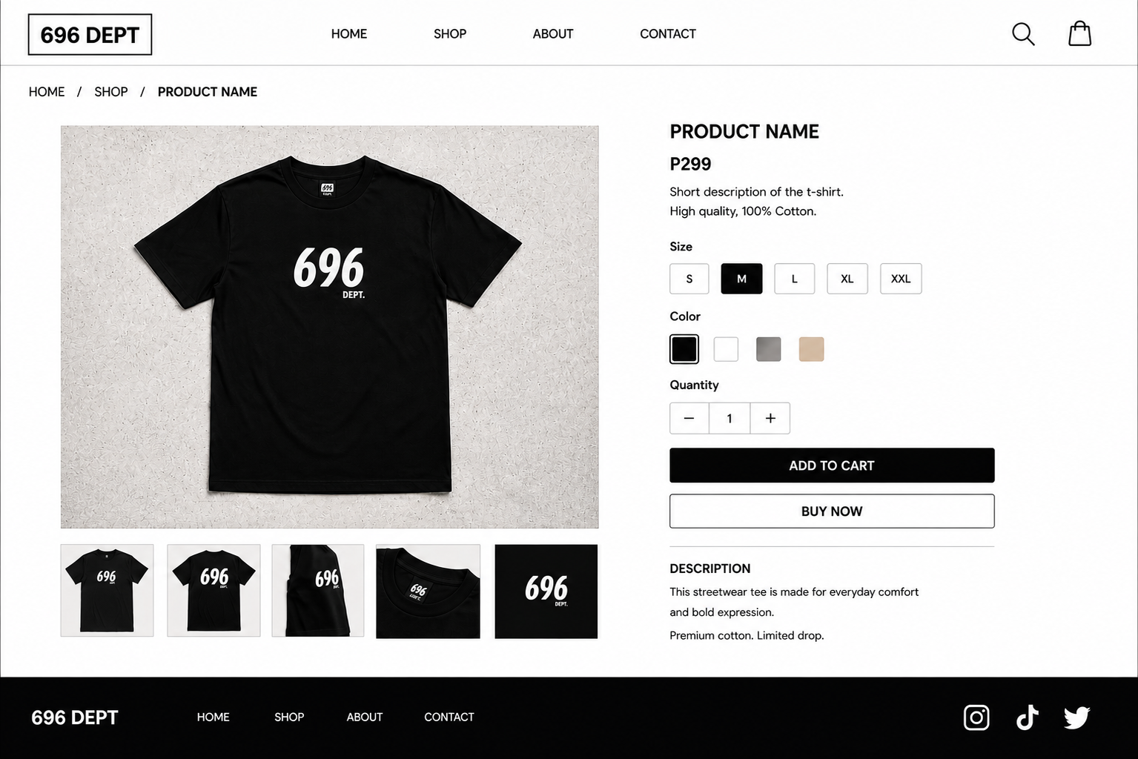

CHECKOUT PAGE
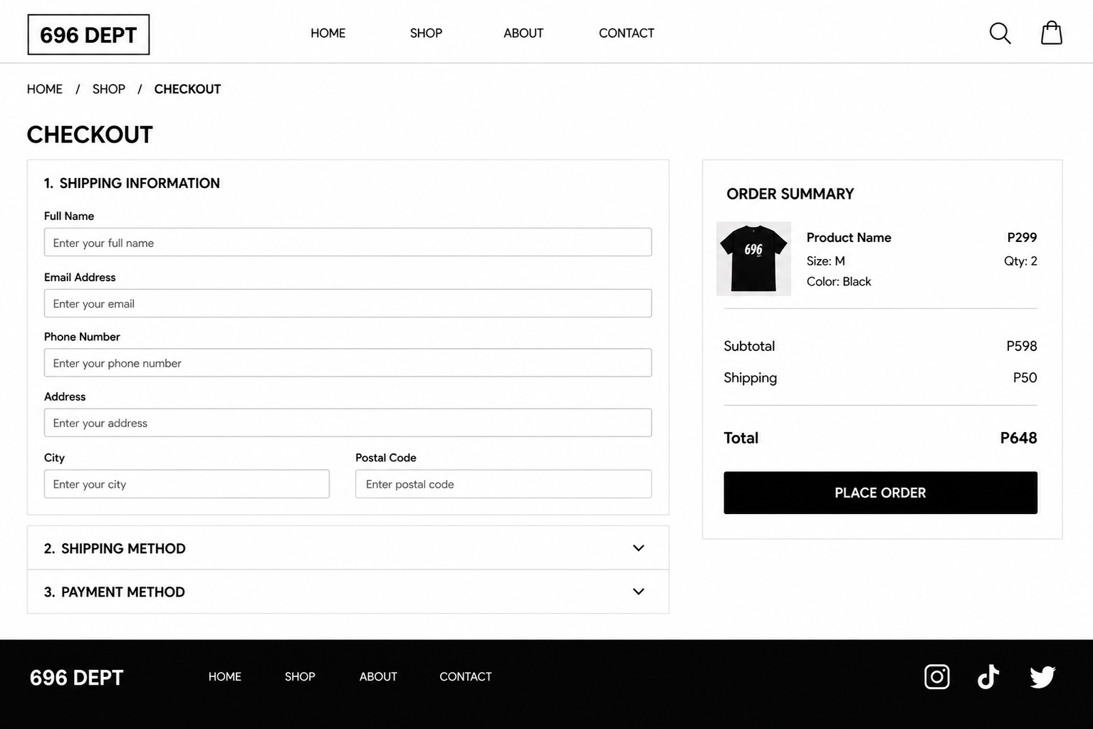

CART PAGE

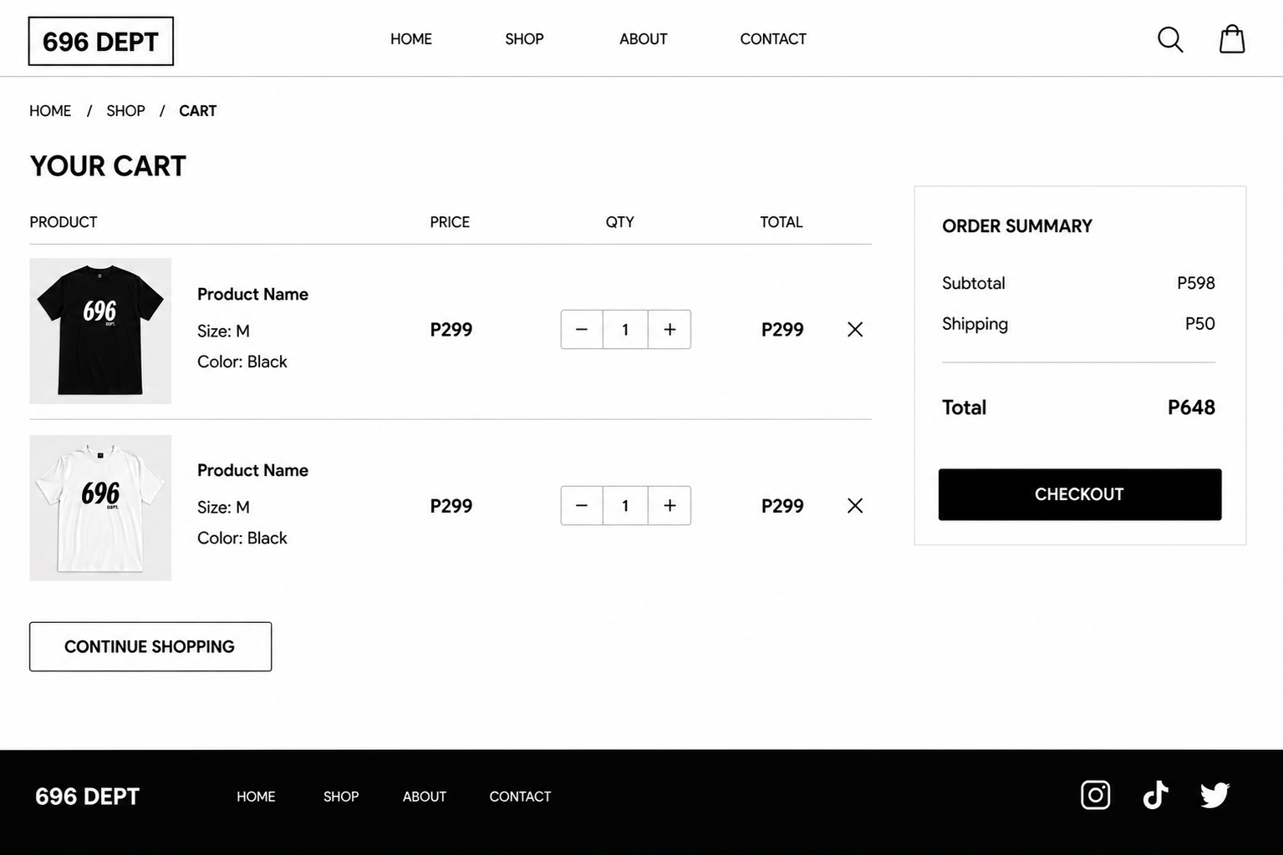

ORDER CONFIRMATION
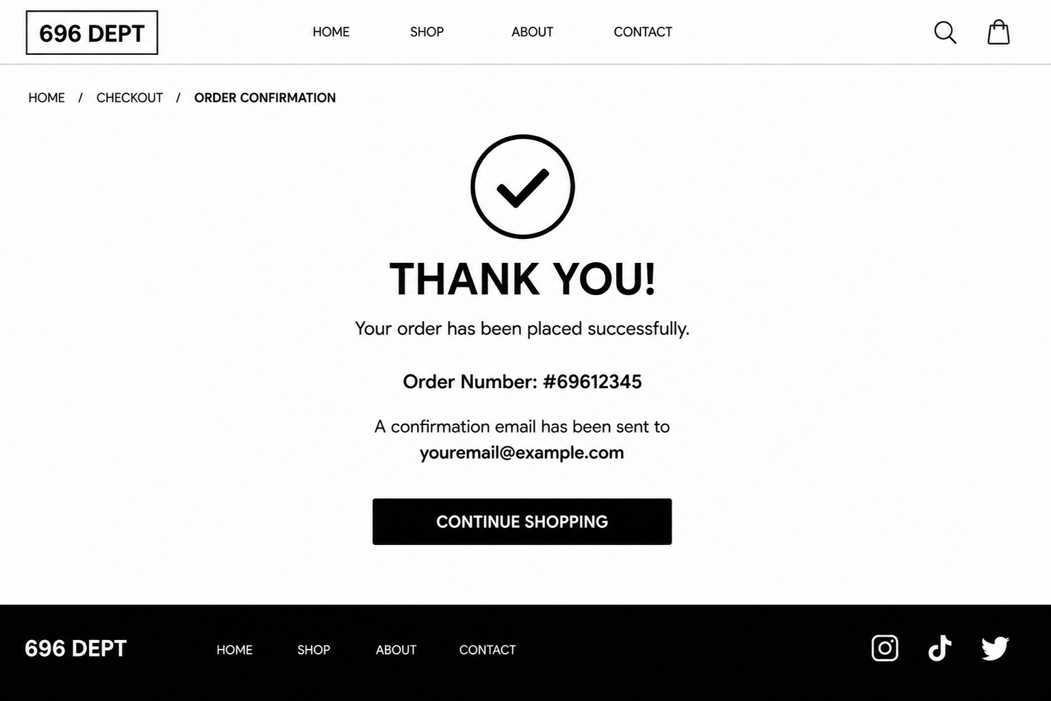
ABOUT PAGE
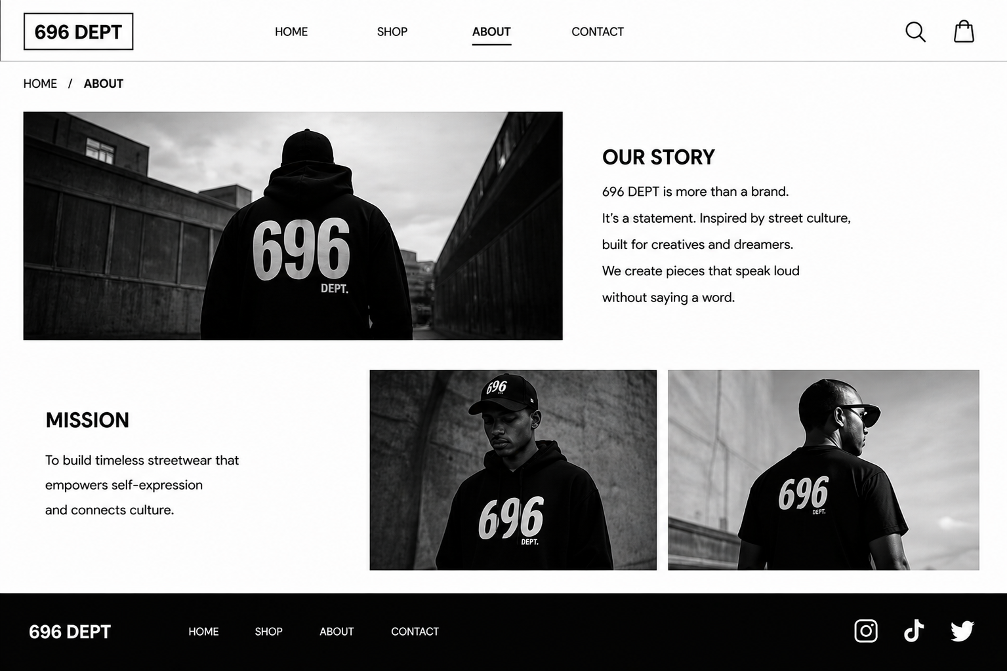

CONTACT PAGE
